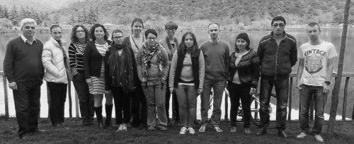
Eastern Partnership Minorities Network

Project summary

The three years collaboration among minority organisations in the Eastern Partnership countries, especially Armenia, Azerbaijan, Belarus, Georgia, Moldova and Ukraine aims at increased capacities and networking between minority activists and organisations.

We also work on their increased engagement with relevant national authorities and their strengthened role within the Eastern Partnership (EaP). It will enable them to effectively participate in democratic and policy processes positively impacting development and human rights for their communities.
In long run it will lead to minority-informed policy development and implementation within the Eastern Partnership.

Countries: Eastern Partnership countries: Armenia, Azerbaijan, Belarus, Georgia, Moldova and Ukraine

We work with activists and civil society organisations, including ethnic, linguistic, national, religious minorities, indigenous peoples and visible minority communities.

Activities:
- Trainings for minority organisations on Eastern Partnership processes and minority rights
- Online training courses on minority rights for local authority representatives
- Establishment of Eastern Partnership Minorities Network and best practice seminars
- Web Portal and Resource Centre for the Network
- Local and National Level Public Information Campaigns by CSOs on EaP and Minority Rights
- Policy Paper on the impact of the Eastern Partnership on Minority Rights implementation
- Advocacy Guide for civil society organisations on the Eastern Partnership
- Shadow reports on minority rights to international monitoring bodies
- National monitoring reports on the impact of EaP programmes on minority rights
- Participation in EaP Civil Society Forum and other regional development fora by minority organisations
- Advocacy visits in Brussels with EU and Eastern Partnership decision makers

Contact:

